HW2

**2.13**

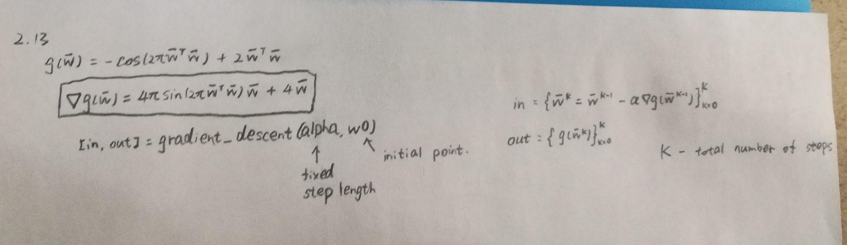

code:

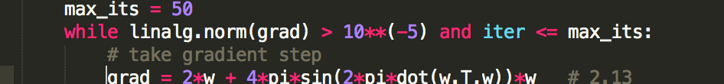

Whole program please see file two_d_grad_wrapper_hw.py

**2.17**

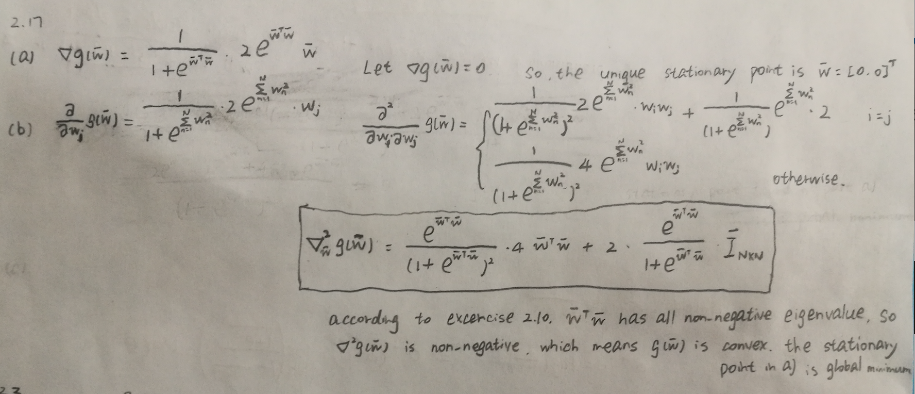

(c)

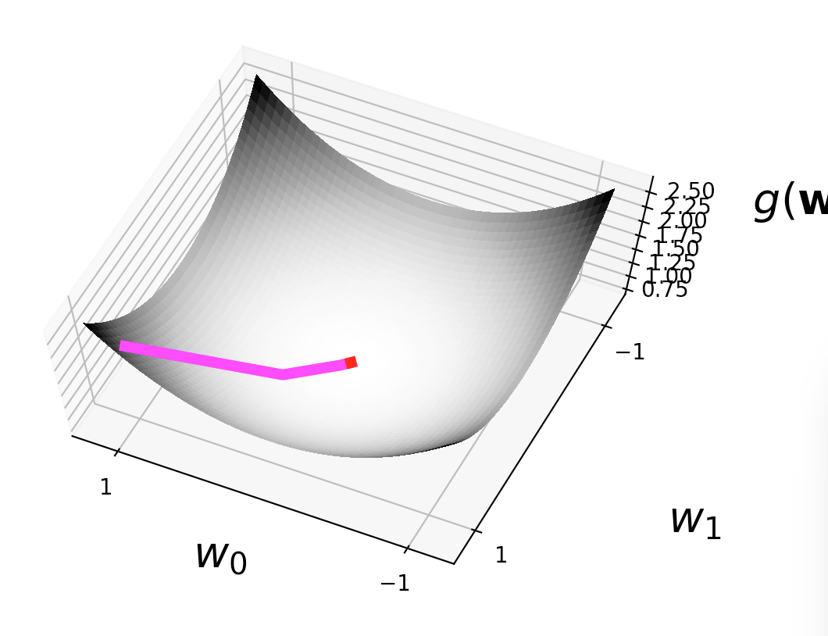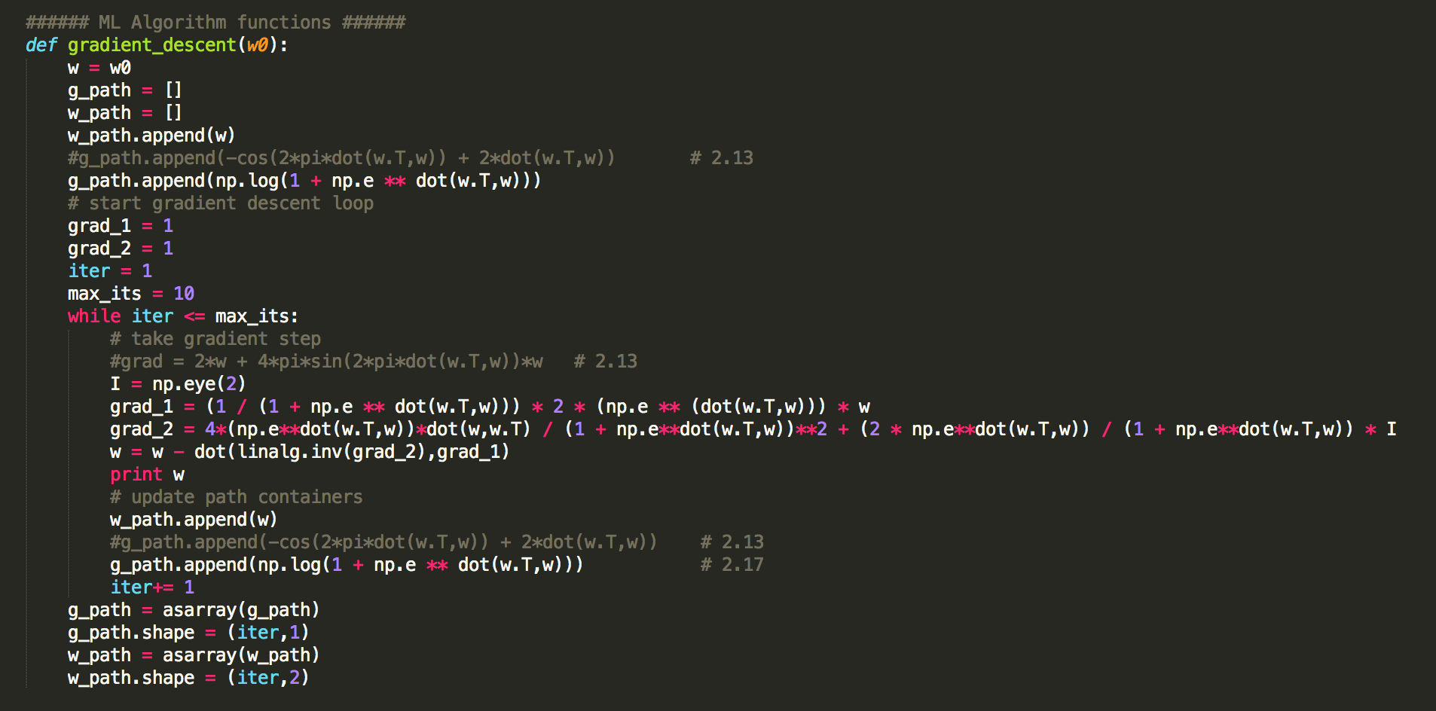

(d)

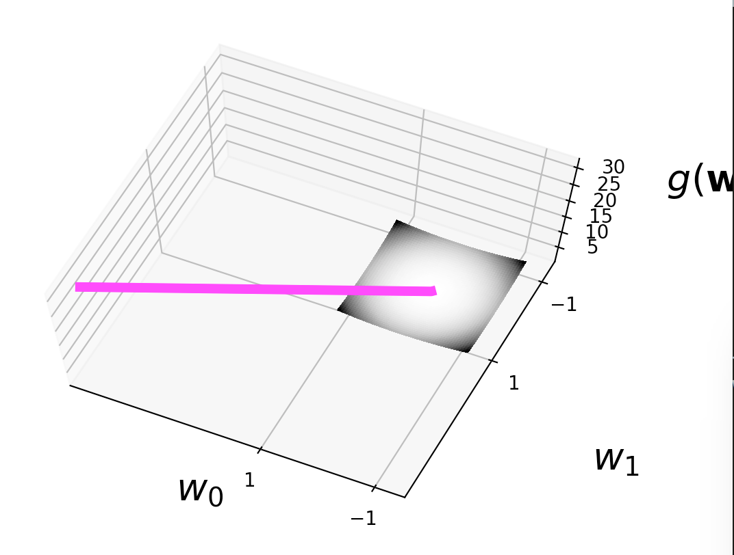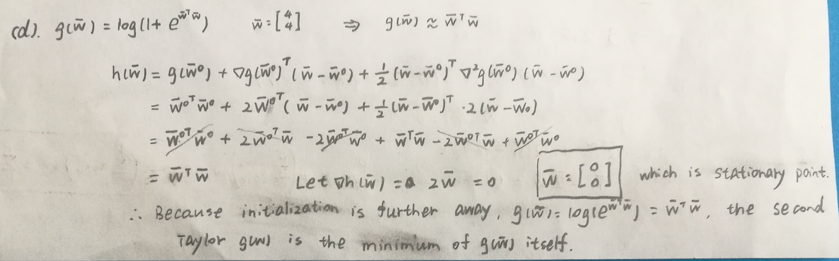

For (c) and (d), please see the file NewTon_Method_2_17.py in zip.

**3.1**

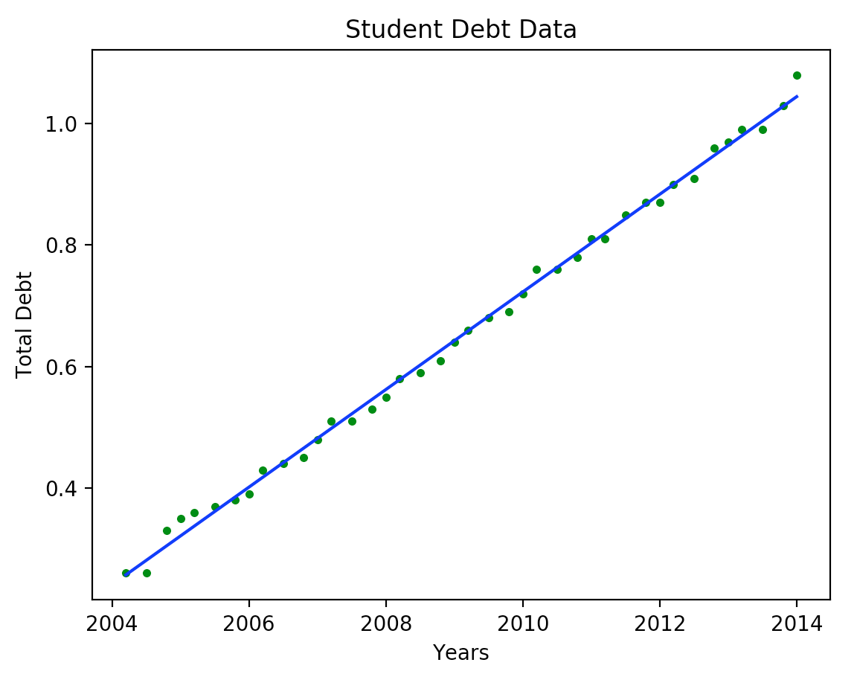

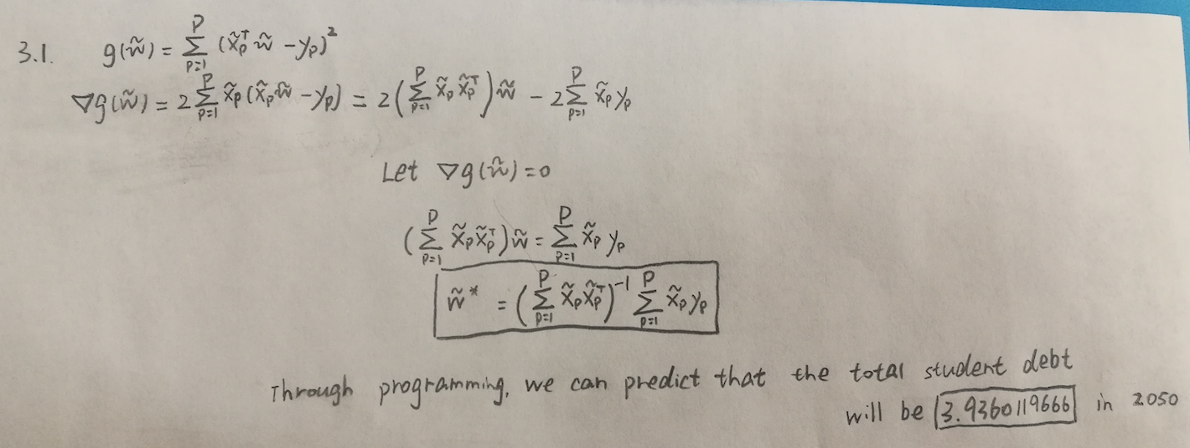

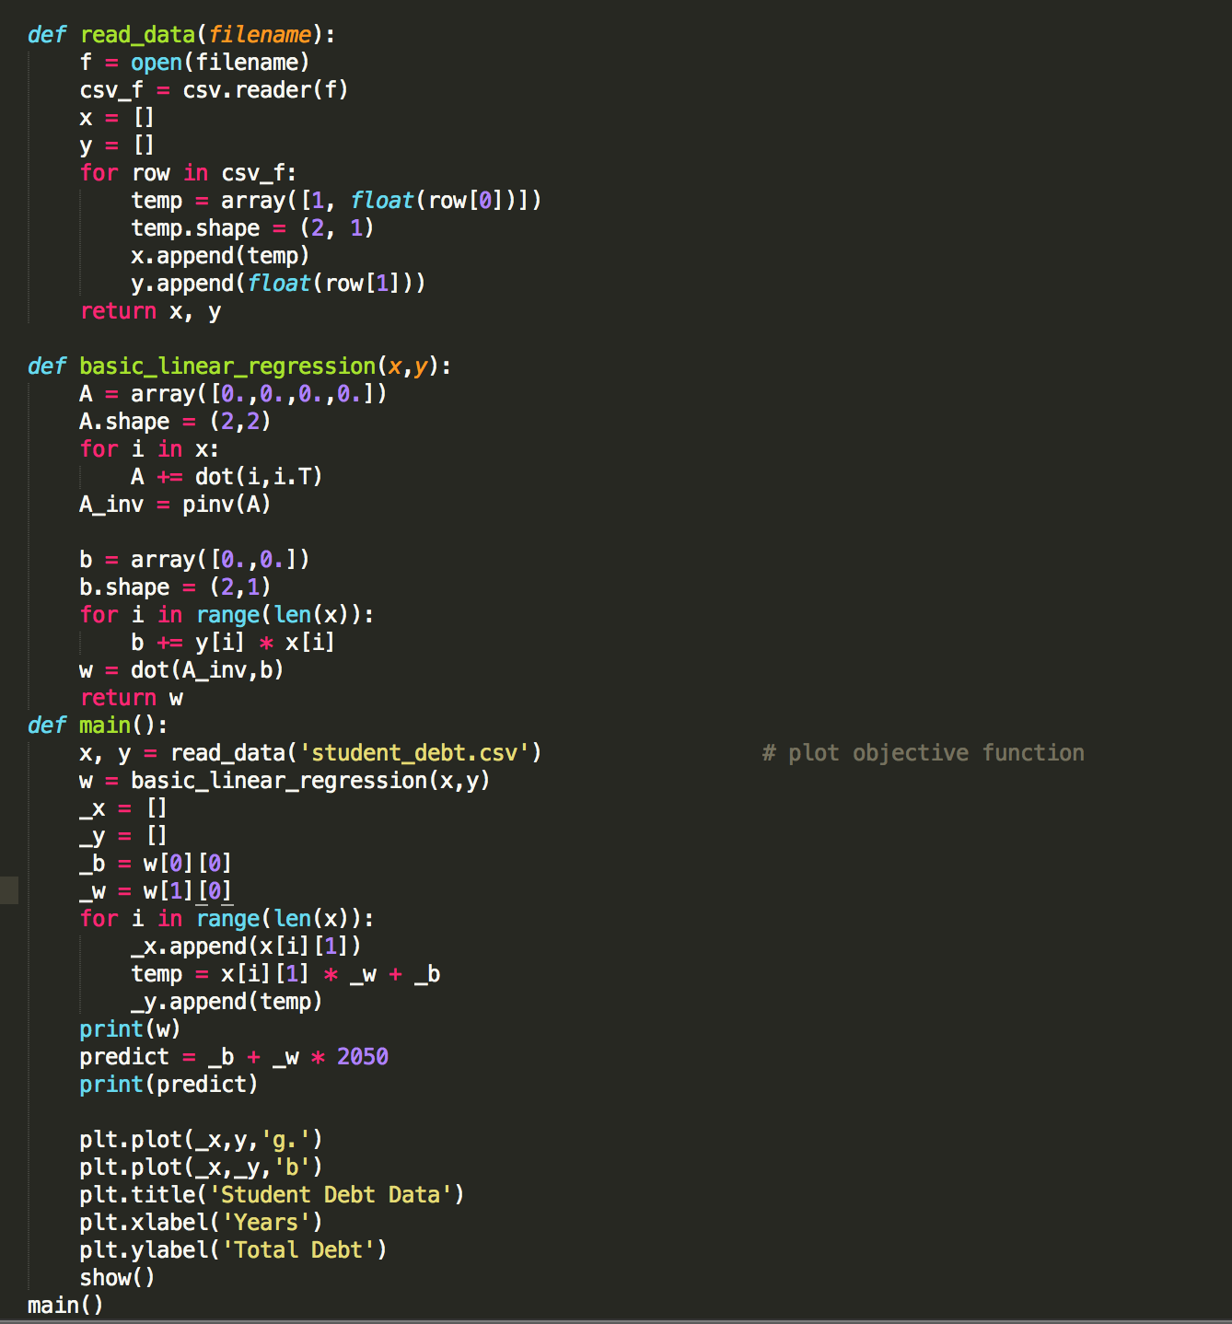

For 3.1, please see the file exercise_regression_line_3_1.py in zip.

**3.3**

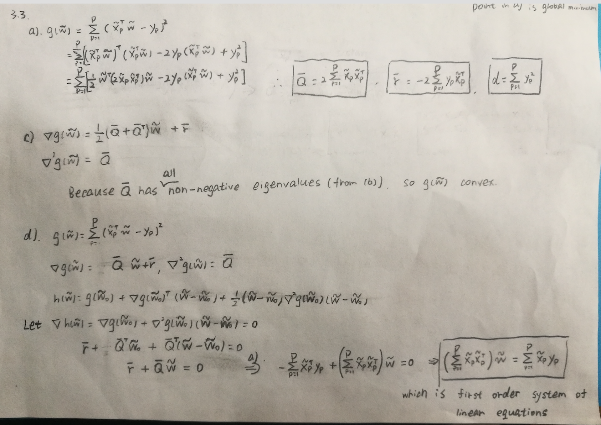

**3.10**

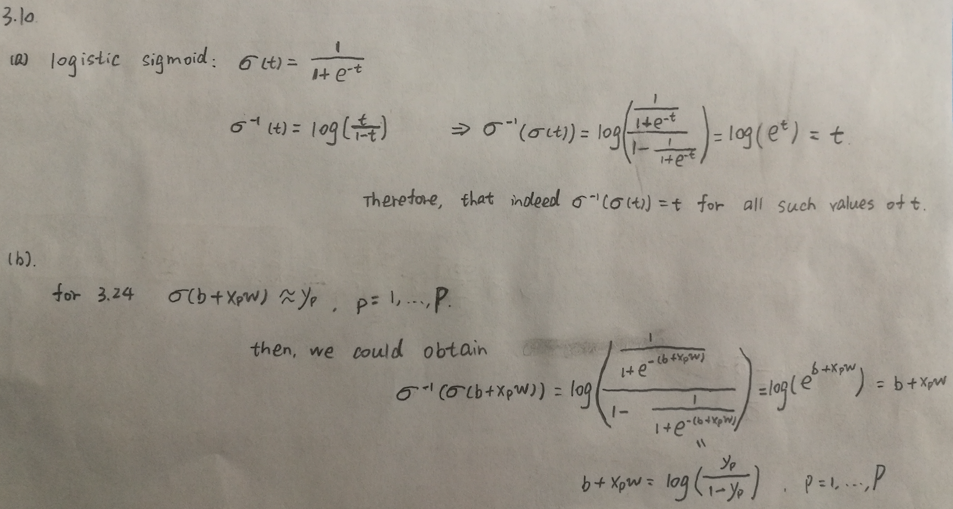

(c)

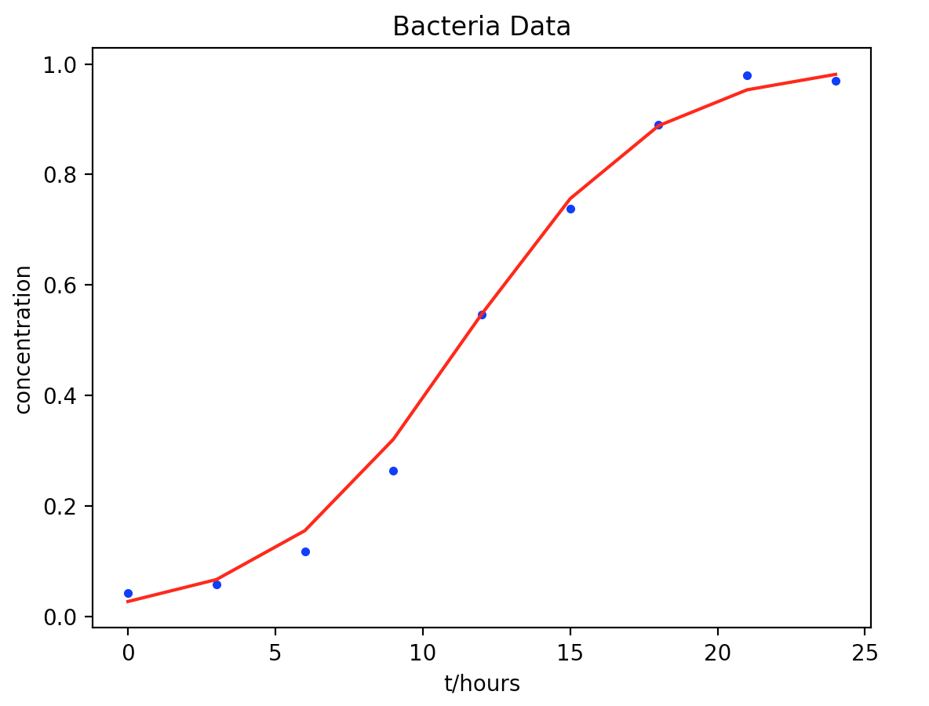

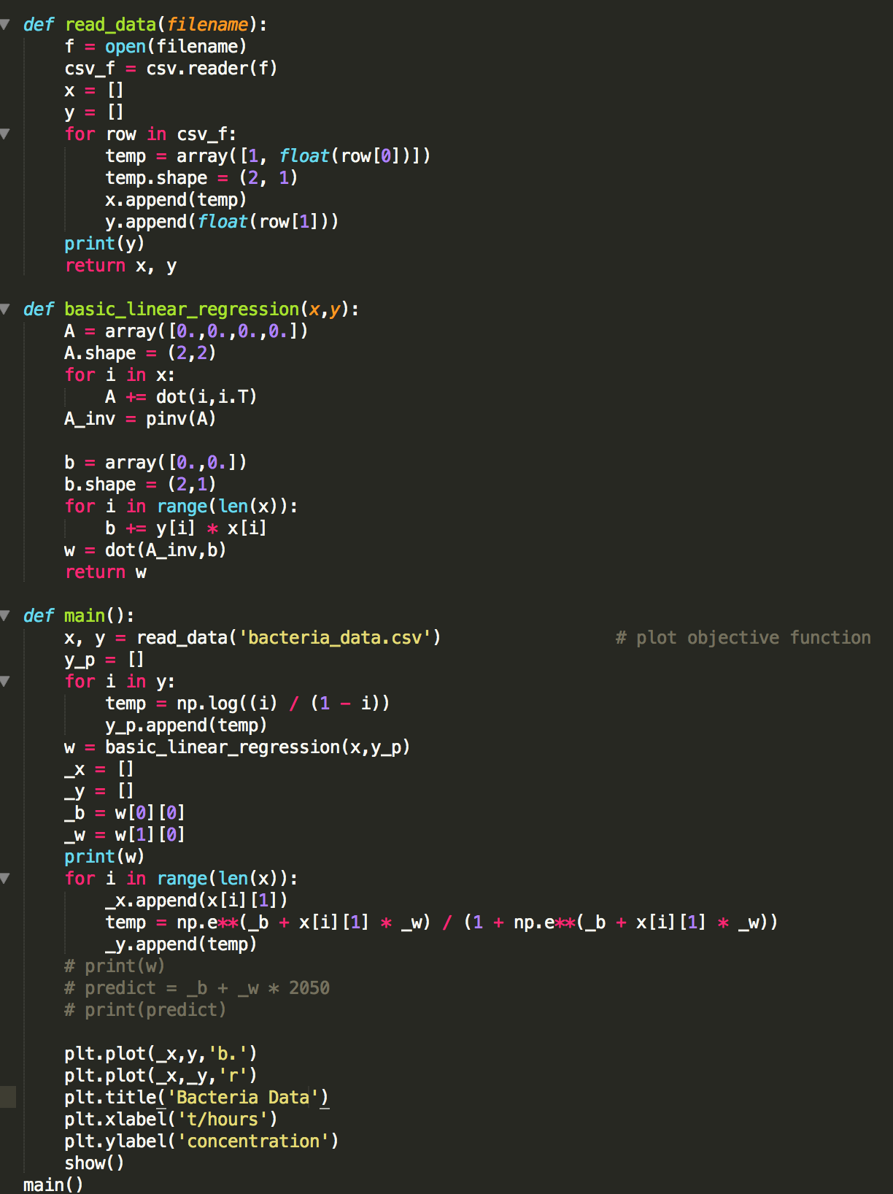

Please see file Logistic_regression_3_10.py in zip